**Labels and Annotations**

* Labels are the metadata that contains identifiable information to the Kubernetes objects. These are basically key-value pairs attached to the objects such as pods
* Each key must be unique for an object
* Labels would appear in metadata section and the yaml would appear as

metadata:

labels:

key1: value1

key2: value2

* Constraints for Labels:
  + Label prefix: This is optional, and this must be a DNS subdomain. This cannot be longer than 253 characters & cannot contain spaces. The label prefix is always followed by a forward slash Eg: directdevops.blog/. If no prefix is used the label key is assumed to be private to the user. label prefixes specific to k8s core system kubernetes.io/ and k8s.io/
  + Label name: The label name is required and can be upto 63 characters long.
* Value of the key in k8s is label-prefix/label-name or label-name

**Scenario: Lets create a ngnix pod with labels organized by team/project**

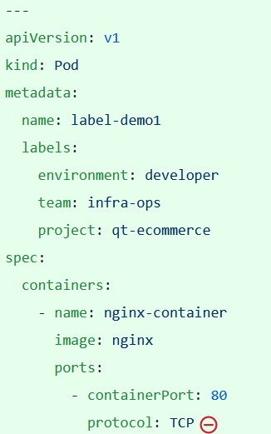

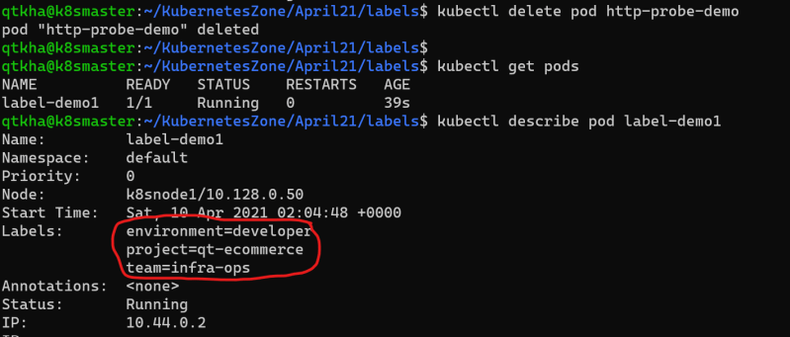

Add labels to k8s object after creation 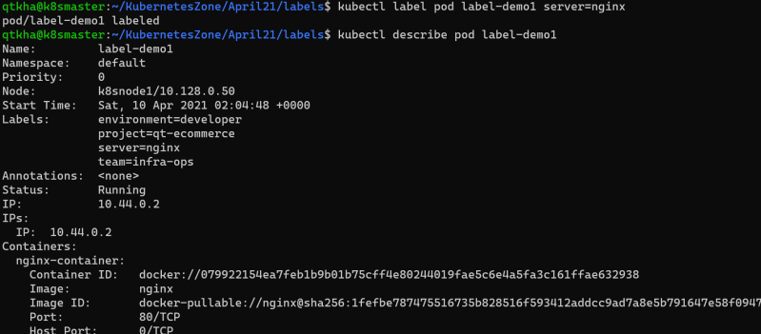

* To create the labels

kubectl label pod label-demo1 server=nginx

* To change the labels

kubectl label --overwrite pod label-demo1 server=nginx-webserver

* To Remove the label

kubectl label pod label-demo1 server-

**Selecting k8s objects using label selectors**

* Let’s create two more pod specs

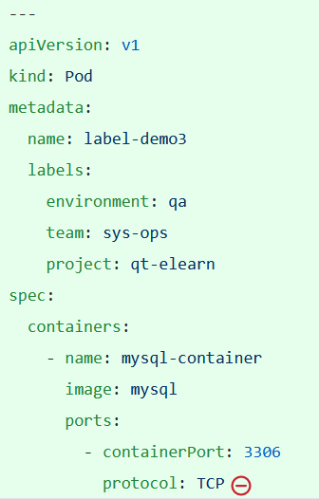

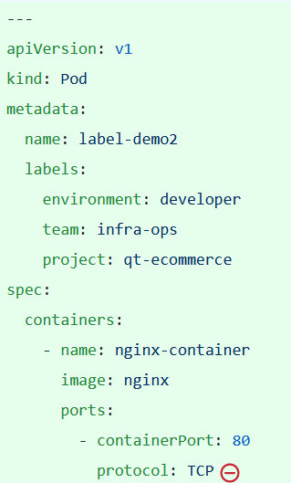

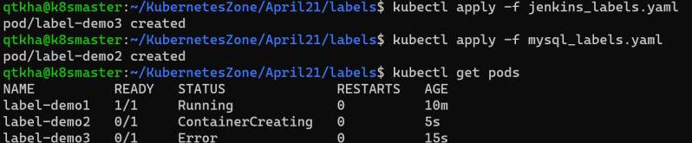

We can query the objects using label selector

kubectl get pods -l {label-selector}

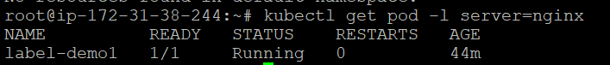

* There are two types of label selectors
  + equality based
  + set-based

Equality based selectors:

In this selector we have three kinds of operators (**=) (==) (!=)**

Lets try to get all the pods with the label environment is equal to developer 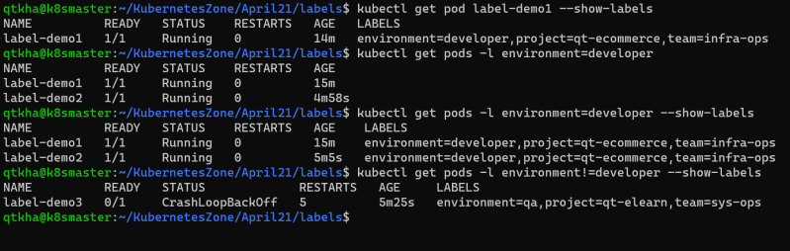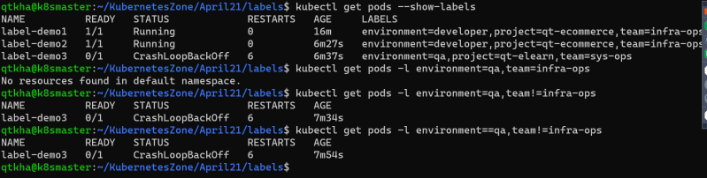

SET-BASED Selectors

* + In this we have 3 kinds of operators **in notin exists**
  + Let’s try some examples 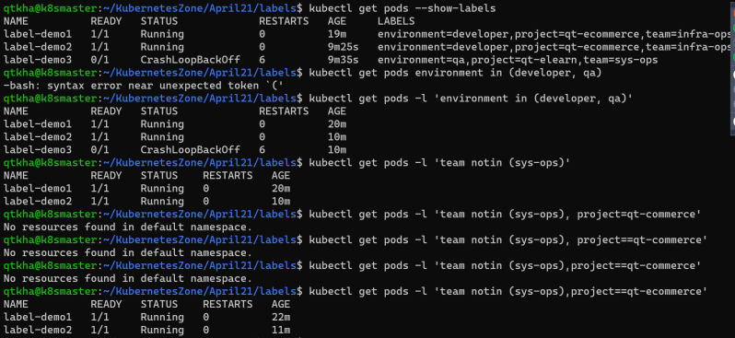

**Annotations**

* Using labels, we can add metadata which can be later used to filter/select objects
* Annotations on the other hand have fewer constraints, however we cannot filter or select objects by annotations
* Annotations are generally used by tools or users to get subjective information regarding k8s object.
* Let’s look at one annotation example
* 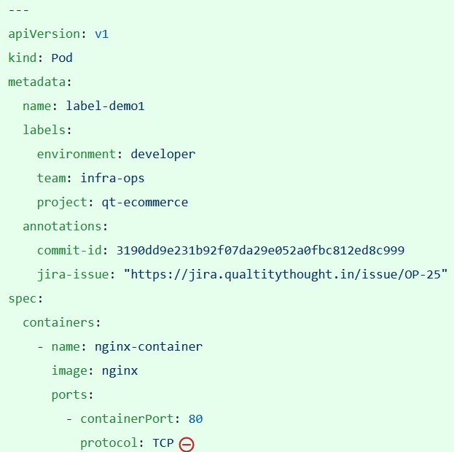

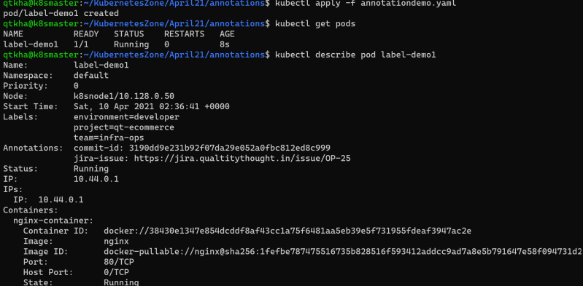

* Like what we have done in labels we can add/modify/delete annotations from kubectl

kubectl annotate pod <podname> <annotate_key>=<annotate_value>

kubectl annotate --overwrite pod <podname> <annotate_key>=<annotate_value>

kubectl annotate pod <podname> <annotate_key>-